# RIT Dev Biz Apps Web Project

# A web-based Inventory system for company of your choice! due Nov 5th!

**?**

You and your team will identify a corporation to work for, then build a web-based inventory system.

Minimum specifications:

1. You will have to set up the technology (flask, python, packages) ahead of time for it to work!
2. Create a web application using the Flask web framework to:
   1. Display a list of all inventory items
   2. When the user selects an inventory item, display complete product information about that item
3. Possible “over and above” extensions:
   1. Allow the addition of new items to the inventory
   2. improve appearance and UI

Please submit this assignment using the myCourses Dropbox section.

*A note about grading: The professor encourages you to go above and beyond these “must-haves” to create a superior program (and earn a better grade). How can you do this?

* **Professionalism:** Think through the problem as if it were your job to really do it. How could it be better for the intended users?
* **New Learning:** Demonstrate new learning from outside the lectures and examples from class.

Please submit this assignment to Prof Perotti using the myCourses Dropbox

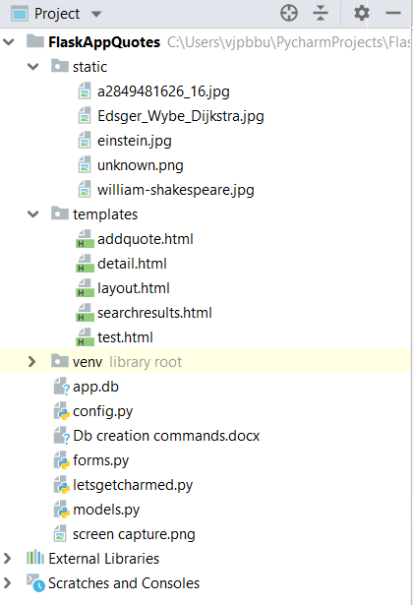Simplest tutorial:

<https://realpython.com/introduction-to-flask-part-1-setting-up-a-static-site/>

One advanced Flask Mega-Tutorial: <https://blog.miguelgrinberg.com/post/the-flask-mega-tutorial-part-i-hello-world>

Another simple Tutorial:

<https://pythonspot.com/flask-web-app-with-python/>